NAME : P.Srinath
ROLL NO: 2403A51015
BATCH-01
SET-A

- Write a Python code to calculate the sum of odd and even numbers in a given list using GitHub Copilot along with VS Code. Use zero shot prompting

PROMPT:
Write a python program that calculate the sum of odd and even numbers in a given list and list as a user input form

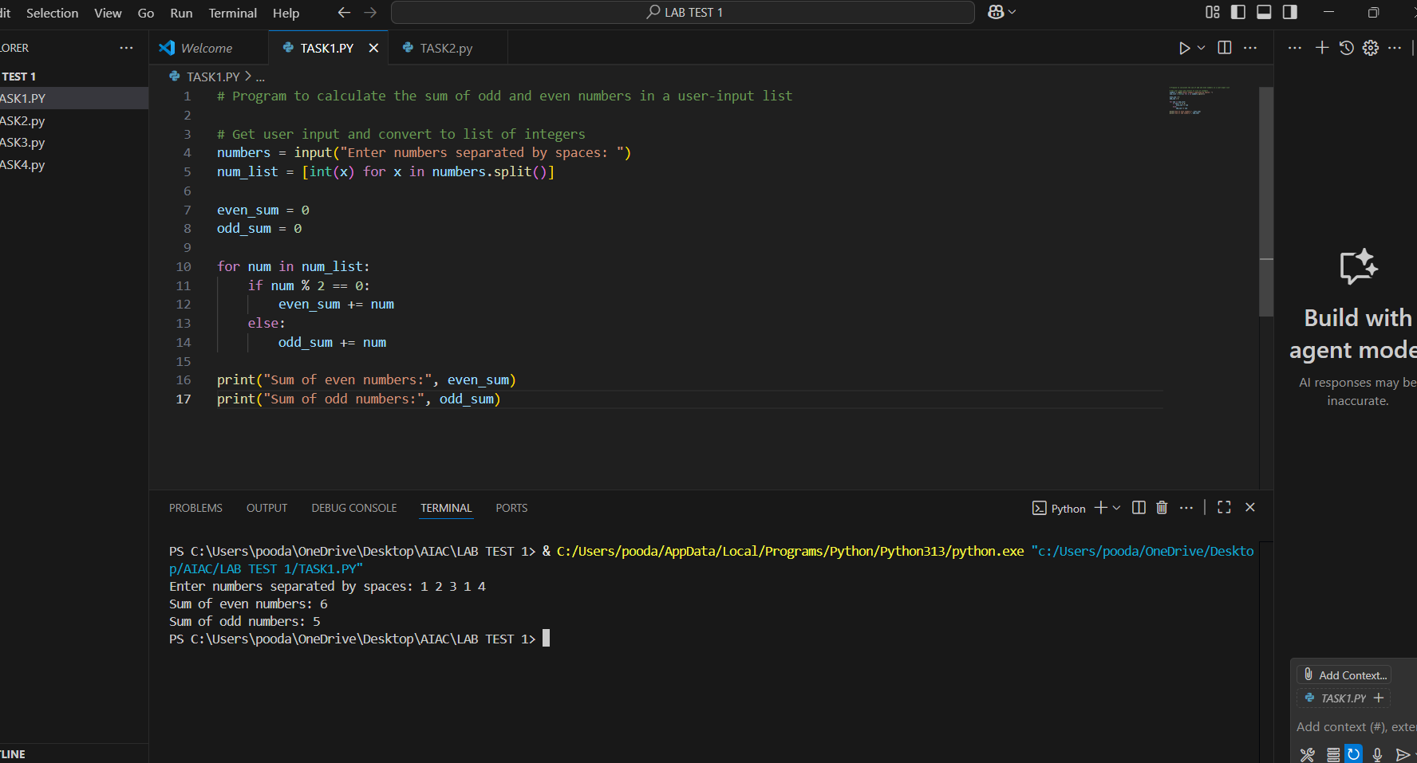

- Write a Python code for given a list of integers, remove duplicates and print the sorted result. GitHub Copilot along with VS Code. Use one shot prompting.

PROMPT :
Write a python program for given a list of integers , remove duplicates and print the sorted result , list as user input form . Example: list=[1,3,5,3,5,7,2],sorted_list=[1,2,3,5,7]

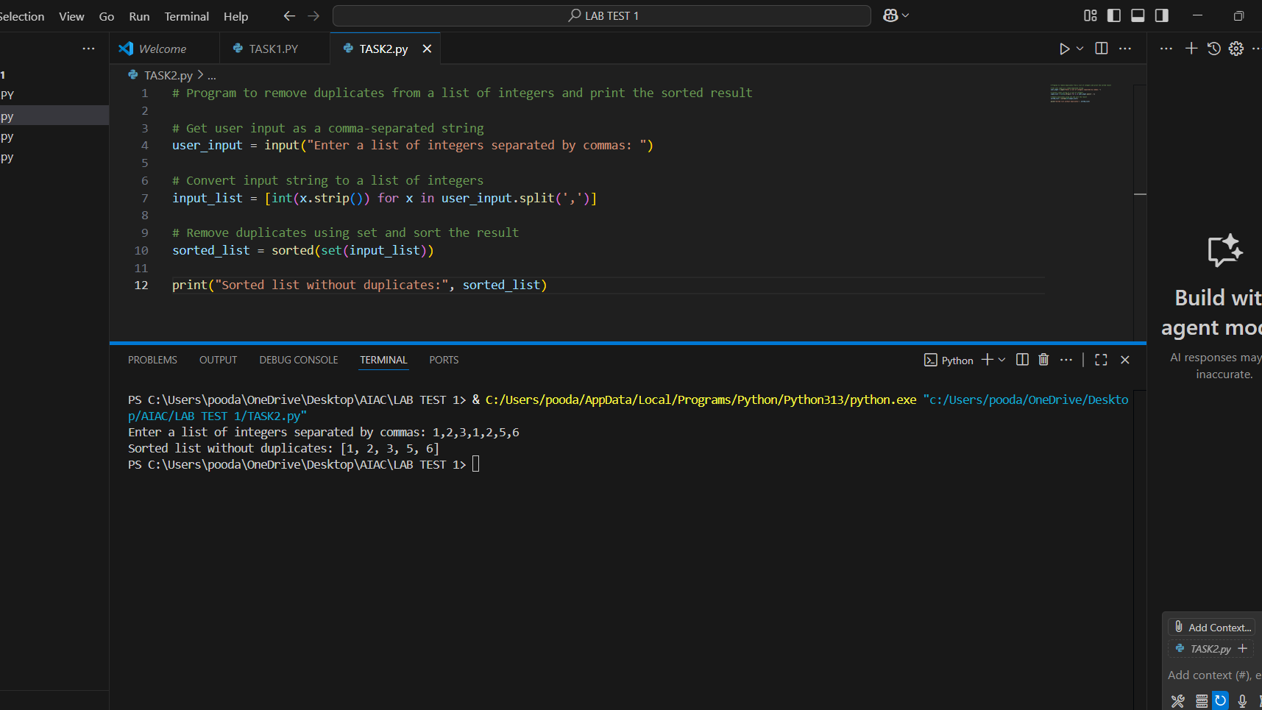

- Write a Python function that converts the temperature between Celsius, Fahrenheit, and Kelvin based on user choice. Use the Cursor AI tool. Use few shot prompting.

PROMPT :

write a python function that converts the temperature between celsius,fahrenhit and kelvin based on the user choice . temperature as user input form . example : 20 c= 68 f, 30 f=272.04 k

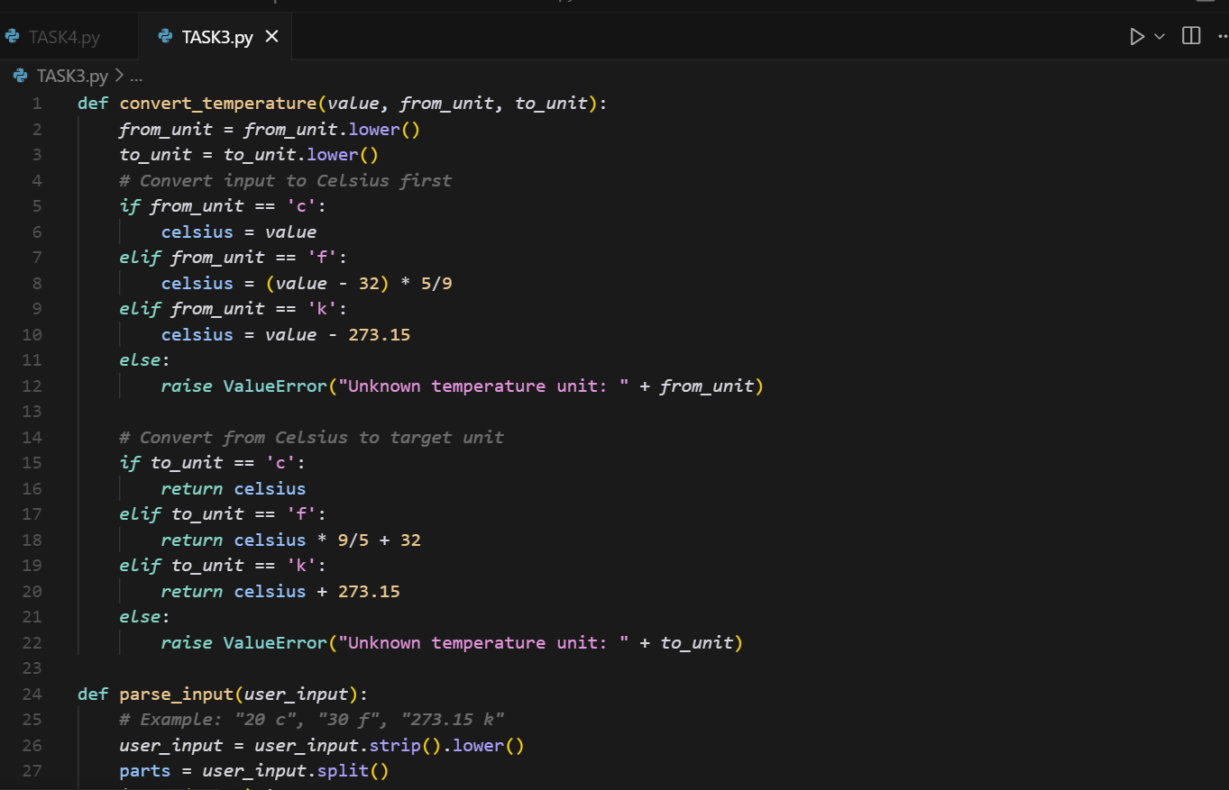

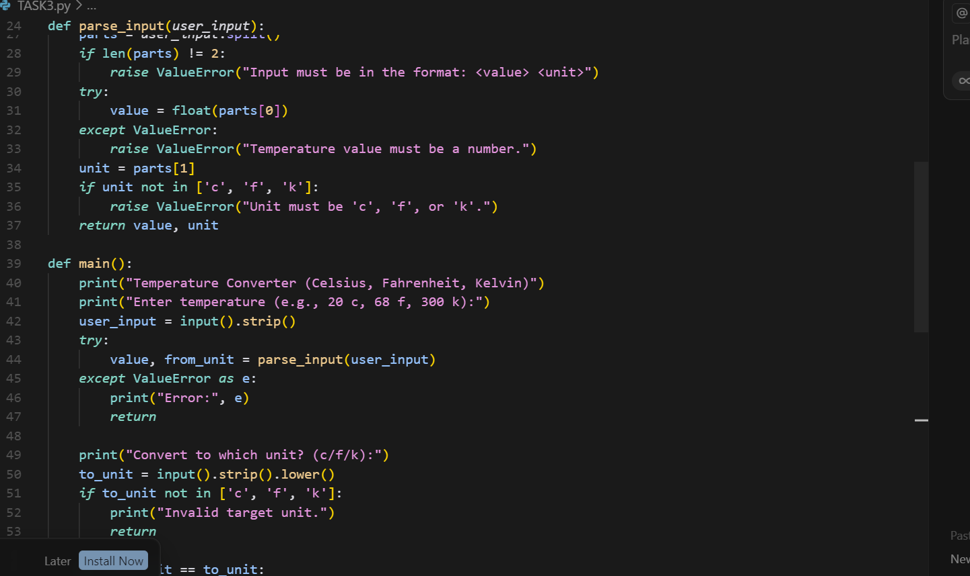

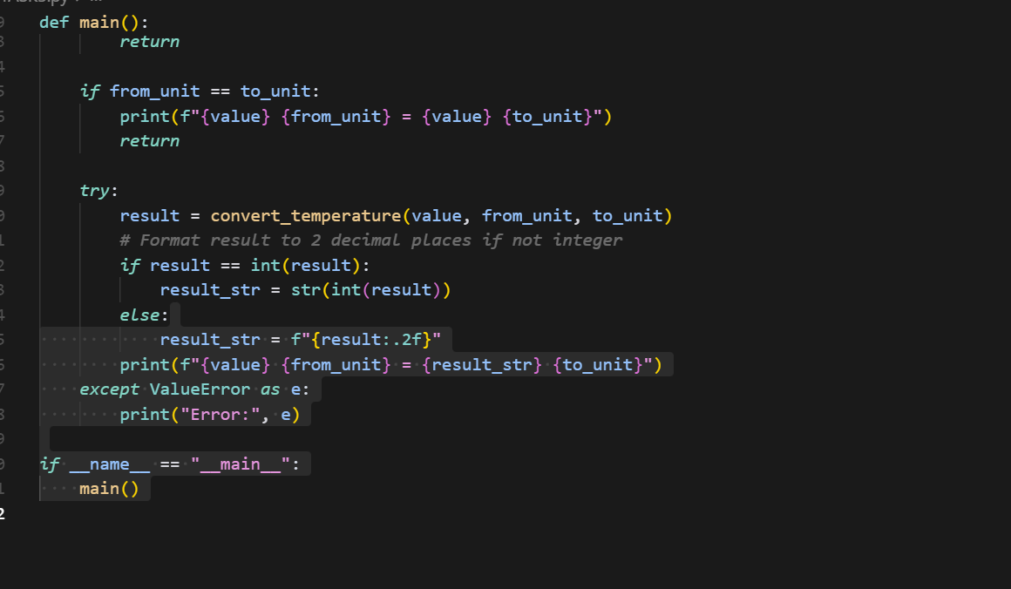

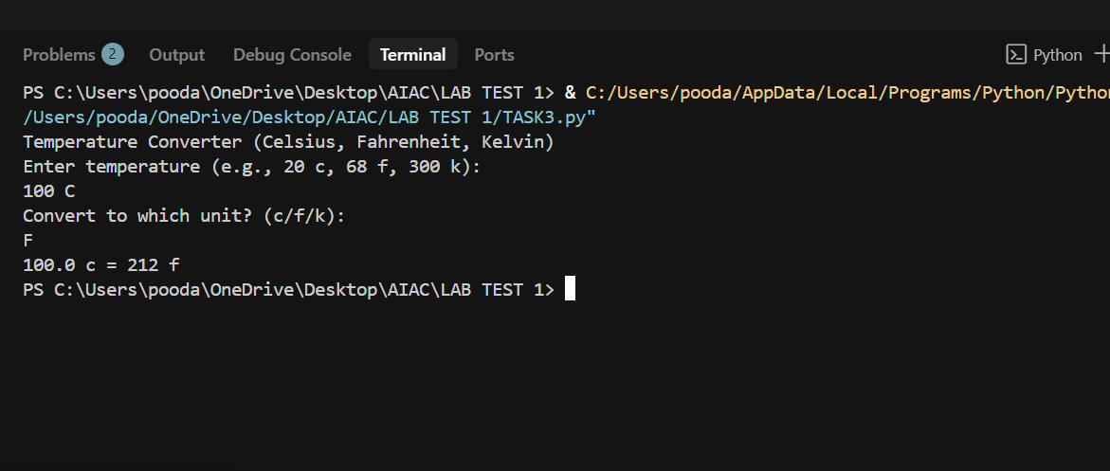

- Write a Python function to remove punctuation, convert to lowercase, and remove stop words from a given text. Use the Cursor AI tool. Use zero shot prompting

PROMPT :

Write a python program remove punctuation, convert to lowercase, and remove stop words from a given text

